Gamebook Computing.
  - Interactive Fiction: Teaching Computing and Computational Thinking through English

Age Range
Suitable for all ages from Upper Key Stage 2 onwards

Resources Required
- A class set of gamebooks. Free online versions are available at: http://www.ffproject.com/
- Gamebook flowcharts - These ideally may be for the story being read and may therefore need to be created. Alternatively, you may use one of the flowcharts attached.

Main Activity
Select a story to begin with the class. You may choose to begin reading the book with the class, explaining the rules and getting the class to make the initial decisions together. Once the tone has been set, divide the class into pairs and encourage them to continue reading part of the story together for a while.
Bring together three different pairs of groups to form a larger group. Each pair should describe the path their story took and compare journeys. It is likely that their stories differed, encourage them to consider how and why this was the case. What decisions made their paths differ?
It is good at this point to bring the class or groups together for a larger discussion to draw out the following ideas:
- What is the difference between a regular fiction book and a gamebook?
- Different pairs had different outcomes for the same story. This was a result of the decisions taken by each pair at each point in the story.
  - Were there any instances where people made different decisions yet arrived at the same outcome? If so, how or why did that happen?
- Encourage several different groups to first consider and then contribute what they think might happen next in the story
What if we wanted a person to follow the same path in the story as us? What would be the best way to make that happen? Encourage groups to spend 10 minutes or so brainstorming and trying out different ideas.
How are books like this made? Ask the students to consider how they would go about writing a book like this.
Explain that the development of the book requires the author to break down each minute element of the story into different parts (Decomposition). Each part will need to be considered separately, and multiple subsequent pathways considered for each element. It can be hard to keep track of this so flowcharts are often used (Algorithmic Thinking). The flowcharts provided with this resource shows partial recreations of the original flowcharts produced by Ian Livingstone when he was writing Armies of Death and Trial of Champions. If any of these books are available it would be a good idea to give students the opportunity to follow the story using the flowchart and comparing the two together, looking at what alternative pathways would have been. Can they track the journeys of their group using the flowchart?
If a different gamebook has been used and a flowchart for it is not available then after students have had the opportunity to look at and discuss the examples provided with this resource, encourage them to follow the storyline they have read so far and create a flowchart from it. The three different pairs in the group should come together to begin to plot the story and the alternative pathways together onto a single flowchart.
For example, for the story Bloodsworth Bayou by Cian Gill (free online interactive gamebook published by the fansite FF Project is available at: http://www.ffproject.com/bayou.htm) the flowchart may look something like the following
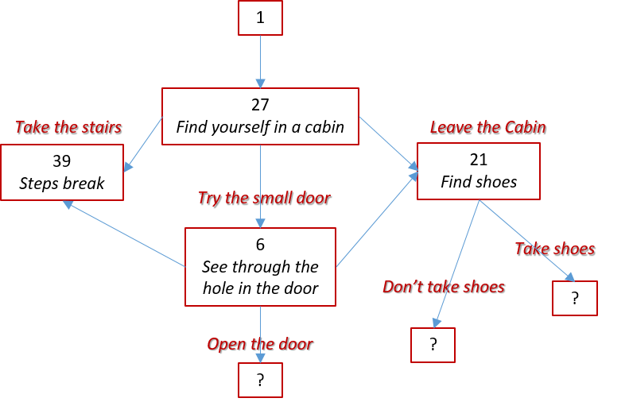

Putting the story to one side encourage students to consider what may happen next. Each group of students should consider the flowcharts they have developed for their story so far and consider suggestions of what may happen next in the story. The group should build upon their existing flowchart and ensure that they consider all elements of the story that could follow on from this point.
NB: the number assigned to each part of the story is a random assignment, designed to ensure that the next part of the story doesn’t simply appear next to the one currently being read.
End the activity with each group presenting their own continuation of the story to the class.

Extended activities
Once students have become familiar with adapting and extending an existing story they can develop their own. In groups/pairs students should generate story ideas and decide on a narrative and draft outline. Together they should draw up a flowchart outlining their story.
- Extending the work with English Lessons: It would be useful to follow this up with work in English lessons, where students can then write each element of their story, thereby constructing and writing their own gamebook.
- Extending the work with Programming: Encourage students to develop and test their own program, possibly using a language such as Scratch or Python, which converts their story into a digital interactive version. A web based version can also be developed by using HTML & CSS script to collate the different elements together. More advanced students will be able to use appropriate script to code additional interactive features that can keep track of common gamebook attributes such as Skill, Stamina and Luck.
- Extending the work with Digital Literacy: For a non-programming focus the story can be presented in multiple environments, from using the interactive features in PowerPoint, to creating an interactive flash animation or alternatively creating audio/video files to support the delivery and presentation of the story.
- Extending the work with Art Lessons: Whether students are presenting their final story as a coded solution or by simply developing a PDF eBook they will need accompanying art work to help bring the story to life. A well designed book cover is an important selling point for any book. Students may design the book cover, game characters, story scenes and other graphical assets to support the presentation of their story and help bring it to life.
There is great potential for extending this work further with students producing their own eBooks which are then made publicly available for their peers to download and read.

Possible Story Ideas (for students to use)
- Maisie has just started her first day at her new secondary school. Help her make the right decisions and so that she can settle in and make lots of new friends
- Nita enjoys downloading music, films and games to use on her home computer. The only problem is that she doesn’t pay for them. What happens when she gets caught?
- Jack loves playing games online with his friends. One day he receives a friend request from someone he’s never met. What happens next?
- Lee’s family move into their new home. It’s quite grand and extremely old, with lots of hidden secrets. What happens when Lee begins to uncover some of those secrets in his new home?
- Magic, monsters and dancing…what do these all have in common?
- Supriya is her school football champion, she’s being head hunted for a major scholarship that could set her on the path to become a professional footballer. There’s only one issue though…

Links with Computational Thinking
A great deal of logical reasoning is required to not just construct a gamebook story but to also follow one through. The fact that the gamebook can be easily represented with a flowchart, which can then be modified and further developed brings in algorithmic thinking. The flowchart also demonstrates how the overall story is broken down into smaller sections which are each then dealt with separately, this demonstrates decomposition; while the overall story itself maybe an abstraction of a real-life scenario. Evaluation techniques will come into play as students review and refine their stories.

Links with the Computing Programmes of Study
The core activity helps develop computational thinking and problem solving which are part of the purpose and aims behind the curriculum. If the work is extended further then activity has the potential to easily meet the statements defined at each key stage for programming, developing creative solutions and possibly e-safety.

Flowchart for Armies of Death by Ian Livingstone
1
37
225
346
145
58
185
274
342
199
33
256
209
107
329
179
286
131
392
21
March
Sail
Barrel
River Raiders TYL
-5M
-2L
-15M
TYL
+10GP
-5M
Hut
Marsh
Mudgrinder
-5M
Start with:
- 100 Warriors
- 50 Dwarfs
- 50 Elf archers
- 20 Knights
E
W
S
N

Flowchart for Trial of Champions by Ian Livingstone
1
49
292
22
310
225
360
78
250
86
End
202
136
275
107
Bonecrusher
TYL
Race
Eat Soup
Attack guard lose 4ST, 1SK

